**Problem Set 6 (Due 4/8/2025 before class in stapled A4-sized paper)**

**Late homework will NOT be accepted, unless you have notified the course instructor 3 days BEFORE deadline.**

**Part I (60%)**

**图片包含 图示

AI 生成的内容可能不正确。**

**Only (a) is to be graded**

**文本

AI 生成的内容可能不正确。**

**Part II (40%)**

1. The graph above represents the potential energy U as a function of position r for a particle of mass m. If the particle is released from rest at position ro, what will its speed be at position 3r0? 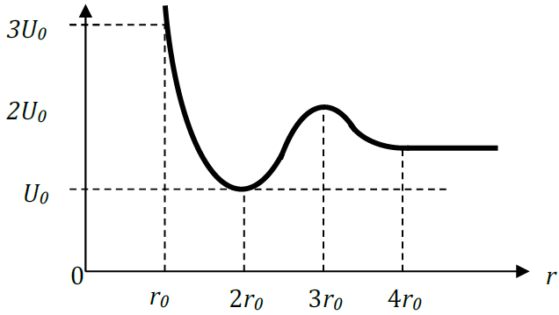

2. The behavior of a non-linear spring is described by the relationship F = −2*kx3*, where x is the displacement from the equilibrium position and *F* is the force exerted by the spring. How much potential energy is stored in the spring when it is displaced a distance *x* from equilibrium?

For problems 3-9: A block of mass *m* rests on a rough surface, and has a light spring of spring constant *k* and unstretched length *d* attached to one side as shown, with the other end of the spring attached to an anchor. There is a static coefficient of friction μs between the surface and the block, and when the block is placed to the right at position 2*d*, it remains stationary on the surface. Express answers in terms of *m, k, d*, and fundamental constants.

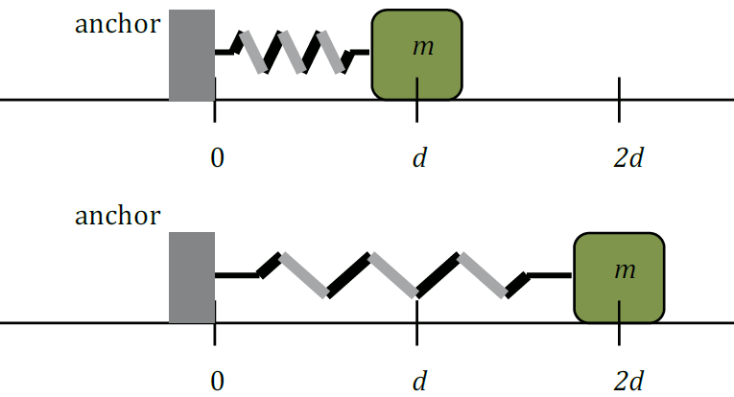

3. Draw a free-body diagram of the block at the time when it is located at position 2d.



4. Determine the friction force acting on the block when it is located at position 2d.

To continue 5-9, the block is now moved to position 3d and released, where it remains at rest. When the block is moved slightly past this position, the block begins to slide along the surface with a kinetic coefficient of friction μk

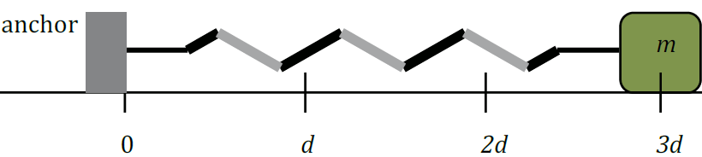

5. In terms of the variables given, what is the value of μs?

6. How much potential energy is stored in the mass-spring system just before the block begins to move?

7. The block slides a total distance of d before coming to a halt again. Determine the

coefficient of kinetic friction μk

8. At what position does the block have its maximum velocity as it slides?

9. What is the maximum velocity of the block as it slides?

10. A mass of 10 kg is taken from the ground for 10 m uphill on the wedge. The wedge makes an angle of 30°with the ground. Find the potential energy of the block.